2022 Annual Planning & Zoning Report

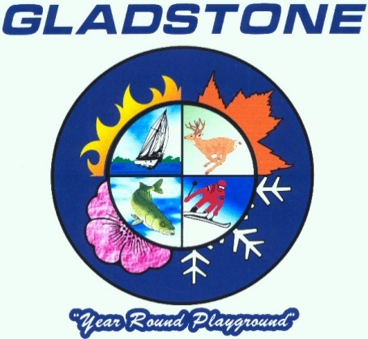

**Planning Commission**

Howard Haulotte, Chairperson

Howard Haulotte, Vice Chairperson/Secretary

Dave Woodworth

Judy Granger

Alger Strom

Dave Nemacheck

Tom Butch

Prepared by:

Reneé Barron

Community Development Director

[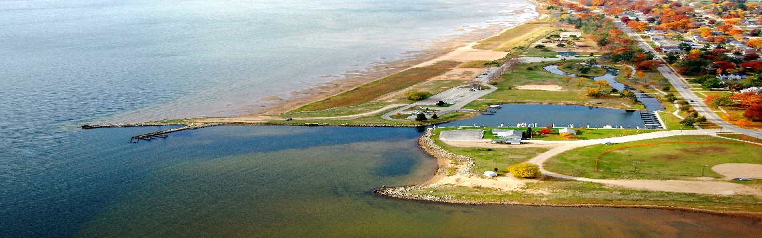](https://www.google.com/url?sa=i&rct=j&q=&esrc=s&source=images&cd=&cad=rja&uact=8&ved=0ahUKEwjv5KKVhsfZAhVm4YMKHRylDUQQjRwIBw&url=https://marinas.com/view/marina/z4c7d_Gladstone_Municipal_Marina_Gladstone_MI_United_States&psig=AOvVaw3fAjGn2OFBTdHF7YRuphVc&ust=1519853577283440)

March 2018

**Purpose of the Annual Report**

In accordance with Michigan Planning Enabling Act, Public Act 33 of 2008, the City of Gladstone’s Planning Commission provides a written report to the legislative body on an annual basis. This report reflects the Planning Commission operations and the status of planning activities and includes recommendations regarding actions needed by the legislative body related to planning and development. The Planning Commission serves to promote orderly development within the city. The purpose of this annual report is to communicate to the governing body and the citizens of the City of Gladstone the activities and status of planning activities within the City of Gladstone.

**What is Zoning**

**2018**

**Meeting Schedule**

**Meetings are held at 5:00 p.m. in Chambers at City Hall on the first Tuesday of the month.**

* **January 2**
* **February 6**
* **March 6**
* **April 3**
* **May 1**
* **June 5**
* **July 3**
* **August 7**
* **September 4**
* **October 2**
* **November 6**
* **December 4**

Zoning is the public regulation of land use; it is the division of a community into districts or zones and the establishment of regulations governing the use, placement, spacing and size of land and buildings. Regulations are found in the text of the zoning ordinance and the accompanying zoning map. The City of Gladstone adopts local zoning codes to enforce regulations to protect the public health, safety and general welfare of its citizens. The authority to adopt zoning is granted to local units of government through the state legislature. Zoning is adopted and enforced to ensure that natural resources are protected, to prevent nuisances, to ensure land use compatibility, to prevent overcrowding and to prevent the overuse of land. Zoning codes adopted must also conserve property values and natural resources.

**The Role of the Planning Commissioner**

The Planning Commission is responsible for implementing local land uses and development regulations. They also play a key role in the development and maintenance of the comprehensive plan (Master Plan). Some of the key roles of a Planning Commissioner are:

* + - * Educate the public on local planning issues, the master plan and land use regulations
* Cooperate and coordinate with other units of government on planning matters
* Prepare, adopt and maintain a master plan
* Review other communities master plans
* Draft and present zoning ordinances and amendments and advise the Commission on various zoning actions
* Review and comment on proposed public works projects

The Planning Commission meets the first Tuesday of the month at 5:00 in Chambers at City Hall. All meetings are open to the public and are posted regularly on our city website: [www.gladstonemi.org](http://www.gladstonemi.org)

.

## PLANNING COMMISSION MEMBERS

The Planning Commission is made up of seven members, serving three year terms. The membership has adopted By-Laws and Rules of Procedure which outline their operations. The membership of the board changed recently because two of our members were promoted to the City Commission.

Brad Mantela our Chairperson left the Planning Commission in October of 2016 as he was appointed to a vacancy created on the City Commission. Brad’s position was filled with Thomas Butch a former Planning Commissioner and retired Attorney. Tom brings a wealth of knowledge and government experience to the board.

Dave Nemacheck was elected to the City Commission in August of 2017 and his position remains open at this time. Each of the City Commissioners are required to participate in a board or committee within the City. Joe Thompson is the assigned City Commissioner to attend our Planning Commission meetings and Joe became our Mayor at the August election. So the Planning Commission is proud to boast that we have two previous Planning Commissioners on the City Commission and the Mayor attends our meetings! The Planning Commission is fortunate to have such an experienced team. John Noreus, remains our Chairperson and Howard Haulotte continues to serve as our Vice Chairperson/Secretary.

Residents wishing to serve as Planning Commission Members may submit application to the City Clerk and applicants are considered as terms expire and/or when an opening has occurred. In addition to fulfilling the duties of a Planning Commissioner, most of our members serve on various sub-committees. These sub-committees enable members, residents and staff to tackle specific issues, concerns and ordinances through workshop sessions. Sub-Committee members report back final decisions or recommendations to the Planning Commission for action. Current members of the Planning Commission are:

|  |  |  |  |
| --- | --- | --- | --- |
| **Name** | **Office** | **Phone** | **Term** |
| **Judy Granger** | Member | 399-5839 | 2019 |
| **Dave Woodworth** | Member | 428-2699 | 2019 |
| **Thomas Butch** | Member | 428-2457 | 2018 |
| **Alger Strom** | Member | 428-2262 | 2018 |
| **Howard Haulotte** | Vice Chair/Sec | 428-9021 | 2018 |
| **John Noreus** | Chairperson | 428-1764 | 2020 |
| **Vacancy** |  |  |  |

## ZONING BOARD OF APPEALS MEMBERS

The City Commission members serve as the Zoning Board of Appeals. The Appeals Board is responsible for hearing variances and appeals on administrative planning and zoning decisions and/or Planning Commission decisions. They are the final board of appeal within the city. There were no Board of Appeals meetings in 2017. Members of the Zoning Board of Appeals include:

|  |  |  |  |
| --- | --- | --- | --- |
| Name | Office | Phone | Term |
| Joseph Thompson | Mayor | 420-1338 | 2021 |
| Brad Mantela | Pro-Tem | 428-2457 | 2019 |
| Dave Nemacheck | Member | 428-9129 | 2021 |
| Darin Hunter | Member | 420-6869 | 2021 |
| Dave Phalen | Member | 241-4625 | 2019 |

## 2017 Year in Review Summary

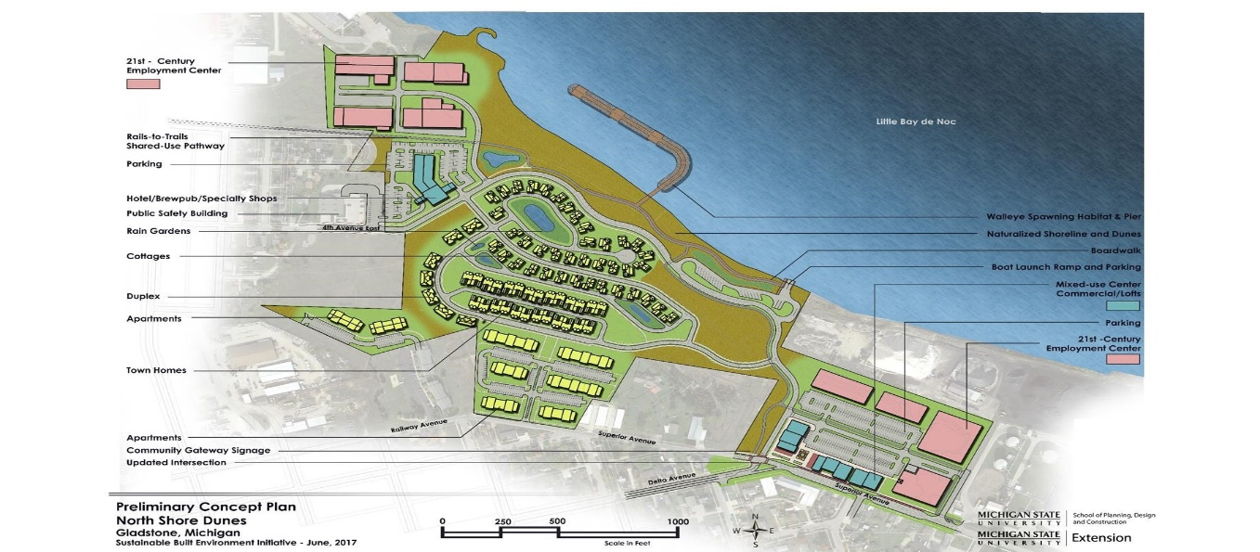

UNIVERSITY

Scale

Feet

In April of 2015 the City applied for Redevelopment Ready Communities (RRC) status with MEDC. Through the RRC the Michigan Economic Development Corporation (MEDC) evaluated us and gave us a report of findings of items to work on to become RRC certified. As part of this process, we received a planning grant through MEDC which initiated a complete rewrite of our zoning code to help us clarify our existing code and to create code for a newly created flex zone which will support a mixed use effort. An additional grant through Michigan State University (MSU) supported us in

completing a community-visioning plan for the North Shore area where the new zoning district is being created. The MSU initiative places emphasis on sustainable planning and design solutions for our community. The partnership with MSU allowed for an innovative approach to help us solve complicated design issues on that property.

*Redevelopment Ready Community (RRC) Strategy/Plan*

Following an intensive RRC assessment process that the City undertook the State identified many strategies the city should work on to improve our readiness to develop. Below are the strategies that are still incomplete and the steps identified to get them completed. Once all of these activities are completed, the City of Gladstone will be granted RRC certification, which makes us more attractive to development and opens the door for additional grant opportunities.

North Shore Visioning Project through MSU Extension

|  |  |  |
| --- | --- | --- |
| Expectation – Redevelopment Strategy | Steps to Completion | Deadline |
| Has the governing body adopted a CIP that details a minimum of 6 years of projects and improvements? | Updated comprehensive CIP will include additional years and prioritized projects | 4/15/18 |
| Is CIP accessible online? | CIP added to website | 4/15/18 |
| Does the community have a public participation plan (PPP) for engaging a diverse set of community stakeholders? | Draft and pass PPP. DDA/EDC Coordinator is actively working on this. | 6/30/18 |
| How does the community share outcomes of the public participation processes? | This will be included in the PPP | 6/30/18 |
| Has the governing body adopted a zoning ordinance that aligns with the goals of the current master plan? | Work with Clear Zoning and the Planning Commission to develop a flex zone district and re-zone areas along North Shore area. Sub-committee has met and is well underway with this task. | Summer 2018 |
| Does the zoning ordinance provide areas of concentrated development in appropriate locations and encourage the type and form of development desired? | Once code amendments are made it will include a flex zone district as well as an overlay of zoning for the downtown. | Fall 2018 |
| Does the zoning ordinance includes flexible tools to encourage development and redevelopment and allow for a variety of housing options? | The amendments will include standards for special land uses and allow for a variety of single and multi-family housing types | Fall 2018 |
| Does the zoning ordinance include standards to improve non-motorized transportation? | This has been completed through the North Shore Visioning Process and the zoning amendments will solidify it. | Fall 2018 |
| Does the zoning ordinance include flexible parking standards? | Develop standards for additional flexible parking requirements. This is being considered during the code review and if more is needed a complete revision of the parking standards will be utilized. | Spring 2019 |
| Does the zoning ordinance include standards for green infrastructure? | Incorporate green infrastructure standards into the zoning ordinance. This will be accomplished through the North Shore Visioning Process and the zoning revisions that will be accomplished. | Fall 2018 |
| Is the zoning ordinance is user-friendly? | Add graphics, a use matrix and hyperlink the ordinance to improve user-friendliness. This is underway and will be completed through the clear zoning revision. | Fall 2018 |
| Does the community annually review successes and challenges with the development review process? | This will be accomplished by developing a customer feedback survey that will be implemented with clients who utilize our site plan review process. | Spring 2018 |
| Does the community maintain a guide to development that explains policies, procedures and steps to obtain approvals? | A formal Guide to Development will be created and located on the cities website to help guide and direct developers through our community’s process. | Summer 2018 |
| Has the community identified and prioritized redevelopment sites? | Two sites have been identified currently (North Shore Property and the Rialto Center). The City Manager is currently working with a student to identify and categorize all redevelopment sites in the City of Gladstone as a resource for developers. | Fall 2018 |
| Has the community identified potential resources and incentives for prioritized redevelopment sites? | Once the sites are identified, available resources & incentives for the sites can be completed. | Fall 2018 |
| Does the community have an approved economic development strategy? | Two strategies that have been proposed for the 2018/2019 budget is a marketing proposal for the Northshore property as well as platting undeveloped land in the Northshore industrial park. | March 2018 |
| Does the community annually review the economic development strategy? | Annual progress reports are made to the governing board and committees for economic strategies, EDA, DDA activities and Planning Commission strategies are outlines in the annual reports. | Complete |
| Has the community developed a marketing strategy? | Our new City Manager has experience in this area and will build a Gladstone-specific marketing strategy plan. This plan will serve as a guide to help with marketing the community to attract business, consumers and real estate development. | Summer 2018 |
| Does the community’s website contain or link to information listed in the Best Practices? | We will add a guide to development link to our website, which will include a host of information for developers, residents, consumers and real estate developers to peruse. | Fall 2018 |

**PLANNING COMMISSION- 2017 SITE PLAN REVIEWS**

D & D Takem Em Kennels was approved for a conditional use in the industrial district in an existing building located at 3201 Sjoquist Drive. The kennel employees 2 people on site and provides boarding, daycare & grooming services for doggie clients.

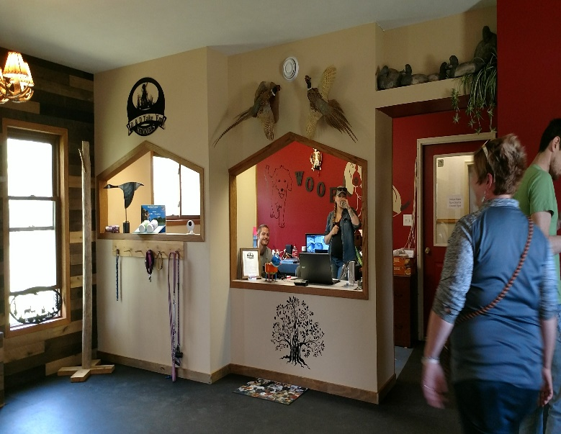

**D&D Tak’em Kennels**

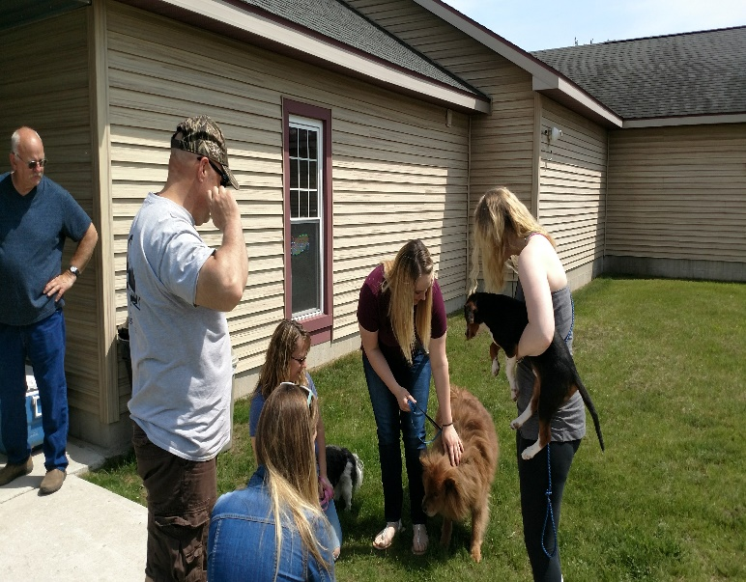**3201 Sjoquist Drive**

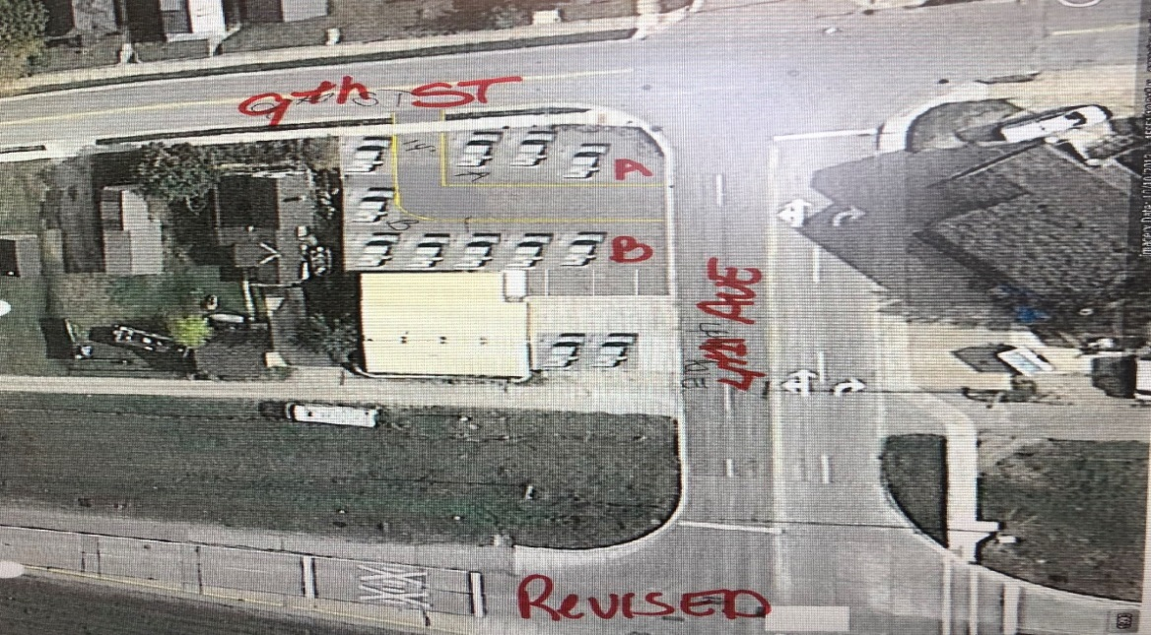A conditional use was approved for a used auto car sales business at 606 North 9th Street. The applicant was Shawn and Sheldon Wallin, although approved this business will not move forward at this location because the owners have decided that the space is not large enough for their business plan.

A conditional use was approved for a 27 hole Disc Golf Course on property owned by the City of Gladstone. The property is partially located in the Gladstone Sports Park and partially in the old landfill area. The golf course will be funded and managed by the Noc Bay Flyers Disc Golf Club.

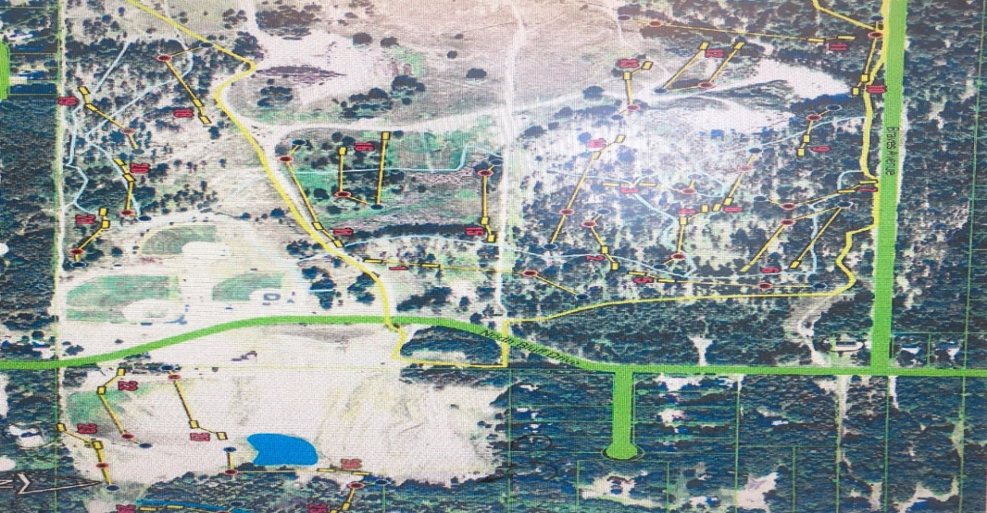

**Gladstone Disc Golf Course**

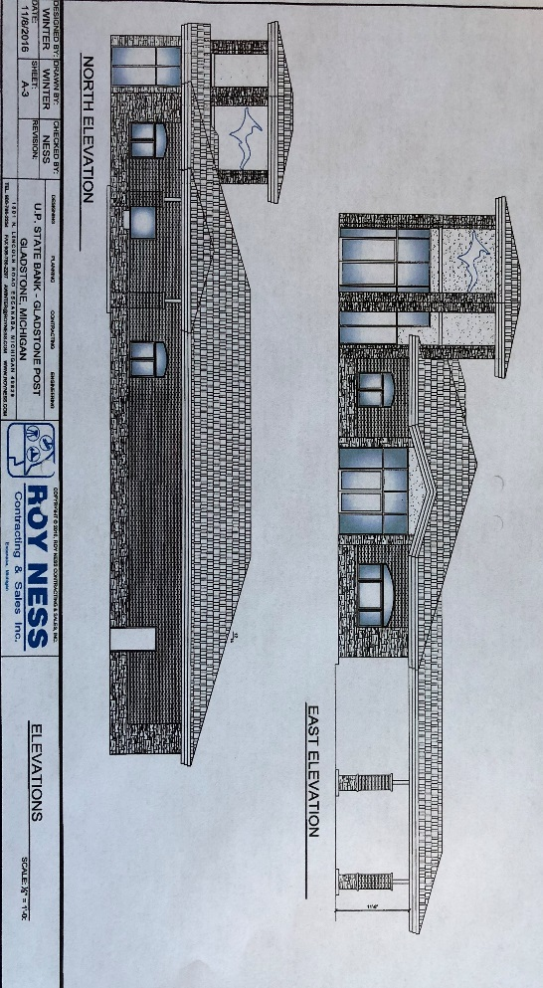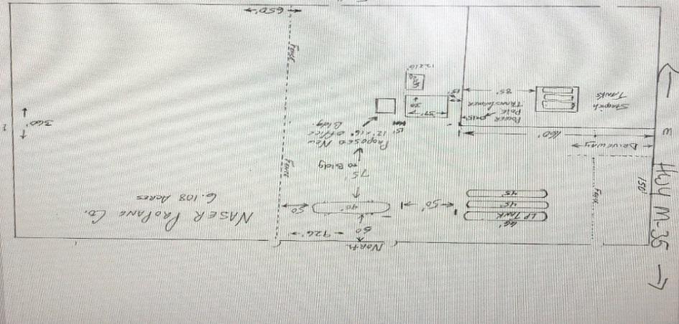Naser Oil added a new 90’ long holding tank to their site located at 3730 Hwy M-35. This tank will help them to meet the increasing demand for propane, all tanks are required to meet state and federal guidelines in addition to our local regulations

**Naser Oil 3730 Hwy M-35**

A new 5,150 SF bank branch was approved at 1 Lowrie Avenue for Upper Peninsula State Bank. This facility is designed to house 6-8 full time employees, host a decorative tower and drive through banking and is a nice addition to the City of Gladstone.

**Upper Peninsula State Bank**

**1 Lowrie Avenue**

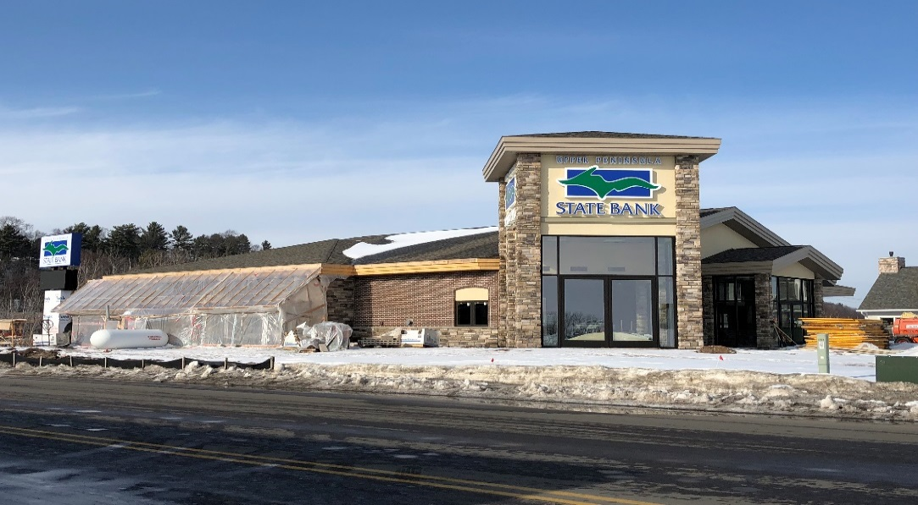

An office building and storage area was approved for 508 Stearns Avenue, the owner of record is Gary Wery. Mr. Wery intends to utilize the space for an insurance office and the larger portion of the building will serve as storage for his other business ventures.

* Administrative Site Plan Reviews Approved
  + 3560 Sjoquist Drive: Payne & Dolan (Expansion of Lab Services)
  + 919 Delta Avenue: Steve Green (Specialty Industrial Parts Distributor)
  + 805 Delta Avenue: Jeff Fleury (Amsoil Retail Supplier)
  + 918 Delta Avenue: Jeremy Cook (Monument Retailer)
  + Third Avenue Right of Way: DTE (Above ground pipe extension)

**TRAININGS/EDUCATION**

Training and education are key components of being a Planning Commissioner and working with the public. Workshops and trainings provide valuable resources for staying up to date on Michigan laws, regulations, trends and upcoming issues.

Trainings attended in 2017 by the Planning Commission and staff includes:

* Board of Review Training
* RRC Best Practices Training
* MSUE North Bluff Visioning Sessions
* MSUE Marijuana Training
* MSUE Marijuana 101
* MEDC Brownfield Training

The Planning Commission maintains membership with the Michigan Association of Planning (MAP) and is a subscriber to the Planning Commissioners Journal. MAP is the only organization in Michigan devoted solely to representing elected and appointed local officials, and professional planners, who share a commitment to making informed land use and planning decisions. They provide regional and online workshops, the MI Planner monthly magazine, publications, guidebooks and offer CEU to maintain certifications. The Planning Commissioners Journal (PCJ) is a yearly subscription that is the nation's principal publication designed for citizen planners, including (but certainly not limited to) members of local planning commissions and zoning boards. The PCJ covers a wide range of planning issues, focusing on how citizen planners can work most effectively.

**Master Plan-2017**

The Planning Commission reviewed our Master Plan in 2015. In 2020 we will be looking to review the plan again. Clear Zoning Consultants were hired to work with the Planning Commission and City Staff to review the Master Plan in 2015, they continue to work with us to propose changes to our planning and zoning ordinances to accommodate and support the goals of the plan. One of the main focuses during the last revision was the development of a flex zoning area along the North Lakeshore. A mixed use development area will be encouraged in this area. It is currently zoned Multi-Family Residential and Industrial. The revised Master Plan demonstrates this area moving towards a mixed use district which will allow for businesses and residential homes to co-exist. The MSU SBEI initiatives, the RRC activities and the Clear zoning revisions will all support this ongoing effort. The Master Plan vision, goals and strategies are listed below, those that are a priority this year are highlighted below in yellow:

Community Vision

Over the next 20 years, the City of Gladstone will expand its assets, offering a better quality of life while maintaining its hometown atmosphere. Gladstone will continue to be a desirable residential community, offer a range of housing options, support a mix of small businesses that serve resident and visitor alike, and work to expand employment opportunities for all residents. Parks and cultural facilities will be expanded, and the city will continue to work with neighboring communities to provide more efficient services and improved facilities. The city will work to maximize the potential of the waterfront.

Goal 1: Redevelop the waterfront in a way that strengthens the city’s connection to the lake and maintains public access to the water.

a. Establish a 100-foot walkway/greenbelt along all city-owned lakefront

b. Develop zoning regulations and consider development incentives that support the creation of walkways and greenbelts along the shore for all future private developments

c. Develop vacant land on the waterfront

i. Identify targeted locations for redevelopment

ii. Create a plan for development of a district on the large vacant waterfront area that supports connections to downtown and access to the waterfront

iii. Support the development plan with revisions to the Zoning Ordinance

d. Develop screening standards for legacy industrial uses on the waterfront

e. Promote mixed-use development along North Lake Shore Drive that will not compete with the downtown district

i. Amend the Zoning Ordinance and map to support this style of development

Goal 2: Develop downtown Gladstone into a regional shopping destination.

a. Support specialty retailing

b. Improve wayfinding signage on US 2/41 and M-35 directing people to downtown

c. Support Downtown Development Authority

i. Continue DDA façade improvement program

ii. Streetscape improvements, including green space and crosswalks

d. Promote residential and office uses on upper stories of downtown buildings

e. Continue to push for a left turn signal on southbound US 2/41 at 4th Avenue

f. Consider ways to promote Gladstone outside of Delta County

g. Create a link between the waterfront and downtown

i. Further develop non-motorized corridor on 10th Street

Goal 3: Develop Gladstone’s business environment to encourage industry, expand the job market, diversify the local economy, and foster commerce.

a. Attract new industry

b. Retain and expand existing industry

c. Develop tourism industry

i. Emphasize recreation opportunities (local and regional) and natural assets

d. Improve off-street parking facilities regulations

e. Improve access to businesses along US-2/41

f. Develop a zoning map and districts that create distinct yet complementary commercial districts in the downtown and along US-2/41

Goal 4: Plan for future residential development in a way that makes Gladstone attractive to potential new residents from all walks of life.

a. Expand the range of housing options

i. Amend the Zoning Ordinance to allow for a variety of single and multi-family residential uses, as well as mixed-use structures in appropriate areas

b. Maintain and rehabilitate existing housing stock

i. Continue seeking funding through state and federal agencies such as MSHDA (Michigan State Housing Development Authority) to continue Homeowner & Rental Rehabilitation Programs

c. Plan for open space in future subdivisions

i. Develop a Conservation Subdivision section for the Zoning Ordinance

Goal 5: Develop the city’s recreation options for locals and visitors.

a. Continue implementation of the city’s Recreation Plan

b. Create a system of neighborhood recreation facilities, and link it together to the extent possible

c. Continue to improve the waterfront

d. Develop a year-round recreation environment

e. Promote Gladstone’s “Walleye Capital of the World” status

Goal 6: Improve non-motorized transportation options, connectivity, and streetscapes across the city.

a. Develop a comprehensive Complete Streets plan

b. Improve connectivity between the bluff and the rest of the city

i. Address the rail crossing on Blackwell

 Goal 7: Plan for long-term sustainability and provision of city services.

a. Plan for the managed extension of public water and sanitary sewer

b. Develop a street maintenance plan

c. Create alternative energy production opportunities

i. Develop zoning regulations for solar and wind energy systems

d. Adopt best practices for storm water management

e. Develop a comprehensive Capital Improvement Plan

i. Include the existing Water Department CIP

**Implementation Program**

Implementation approaches to the goals and recommendations of the master plan are outlined on the following pages. These strategies constitute actions or series of actions that can be taken to reach a stated objective, after which the work will typically change to achieve a follow-up objective.

|  |  |  |  |
| --- | --- | --- | --- |
| **Objective** | **Strategy** | **Priority** | **Timeframe** |
| **Goal 1: Waterfront Redevelopment.** Strengthen the city’s connection to the lake. | | | |
| Preserve public access to the water. | Establish a 100-foot walkway/greenbelt along all city-owned waterfront. | PC  PC  PC | Mid-term    Mid-term    Mid-term |
| Consider incentives to opening access to the privately owned lakefront. |
| Develop regulations to preserve water access in future development. |
| Plan for development of vacant waterfront property. | Identify targeted locations for redevelopment. | PC & CC  PC & Staff    PC | Completed        Completed      In Progress |
| Create a plan for development of a district on the large vacant waterfront area that supports connections to downtown and access to the waterfront, including a regulatory framework. |
| Support the development plan with revisions to the Zoning Ordinance. |
| Promote harmony between industrial and non-industrial uses on the lakefront. | Develop screening standards for industrial uses. | PC & Staff | In Progress |
| Understand potential challenges to development of the waterfront. | Inventory property disposition, site history, and public attitudes toward potential projects on the site. | City Manager | Near-term |

|  |  |  |  |
| --- | --- | --- | --- |
| **Objective** | **Strategy** | **Priority** | **Timeframe** |
| **Goal 2: Downtown Gladstone.** Develop downtown into a regional shopping destination. | | | |
| Nurture a mix of specialty and anchor businesses that serve both residents and visitors. | Develop a business recruitment strategy and action plan, including a business recruitment package. | City Manager & EDC  PC & EDC  EDC  City Manager | Mid-term    Long-term    Long-term    Near-term |
| Allow innovative uses such as shared kitchens, pop-ups, and entrepreneurship incubators. |
| Explore property owner/business owner interest in establishing a Business Improvement District. |
| Develop online and print tools to promote awareness of downtown businesses. |
| Promote upper floor residential. | Seek capital to fund matching loans for life safety and other upper floor improvements that enable residential conversions. | CD  CD | Mid-term    Mid-term |
| Promote upper floor redevelopment to downtown property owners, highlighting financial benefits. |
| Improve gateways to downtown. | Consider a similar project to the 10th Street improvements on Delta Avenue. | City Manager & Staff   DPW | Long-term    Near-term |
| Pursue the wayfinding plan found later in this chapter. |
| **Goal 3: Economic Base.** Encourage industry, expand the job market, diversify, and foster commerce. | | | |
| Expand job opportunities industry through attraction, retention, and expansion. | Develop a schedule of retention visits to all industrial tenants in the city. | EDC  EDC  PC  City Manager | Near-term    Long-term    Mid-term    Mid-term |
| Consider acquiring additional vacant industrial sites. |
| Streamline approval processes for upgrades and expansions to existing facilities. |
| Actively market industrial properties via the MEDC and to trade groups. |
| Promote harmonious relationships between land uses. | Improve off-street parking regulations. | DPW & PC  Electric & PC | Mid-term    Mid-term |
| Develop screening and lighting standards for non-residential sites. |

|  |  |  |  |
| --- | --- | --- | --- |
| **Objective** | **Strategy** | **Priority** | **Timeframe** |
| **Goal 4: Residential Development.** Make Gladstone attractive to new residents. | | | |
| Shore up future population levels. | Market the city as a family-friendly place with excellent schools. | City Manager | Mid-term |
| Accommodate the city’s growing senior population. | Enable residential retrofits for accessibility and plan for a diversity of housing styles. Adopt standards for adult foster care. | PC | Mid-term |
| Expand the range of housing options. | Amend the Zoning Ordinance to allow for a variety of single and multi-family residential uses, as well as mixed-use structures in appropriate areas, as determined by the Planning Commission. | PC | In Progress |
| Maintain and rehabilitate existing housing stock. | Re-establish the city’s Homeowner & Rental Rehabilitation programs. | CD  CC & CD   CD | Mid-term    Completed    Near-term |
| Enhance code enforcement for residential properties, emphasizing vacant homes. |
| Develop a set of neighborhood beautification awards. |
| Plan for open space in future subdivisions. | Adopt fuller standards for open space subdivisions. | PC | Mid-term |
| **Goal 5: Environment & Recreation.** Develop recreation for locals and visitors, consider natural spaces. | | | |
| Develop a year-round recreation environment. | Pursue grants to execute the city’s adopted recreation plan. | Rec | Completed  & Ongoing |
| Plan for the future of undeveloped land in the city. | Establish a public input process for developing a vision regarding whether and how to develop remaining natural spaces within the city. | City Manager | Completed |
| Protect the city’s water assets. | Adopt storm water management best practices, as outlined by the EPA. | DPW | Long-term |
| **Goal 6: Complete Streets.** See the Complete Streets plan later in this chapter. | | | |
| **Goal 7: Sustainability and Services.** | | | |
| Plan for the managed extension of city services and maintenance of existing assets. | Develop a comprehensive Capital Improvement Plan for the city. | City Manager | Near-term |

**Marketing & Wayfinding Strategies**

Marketing the city is a key to expanding the tourism industry, and can support expansion of retail options and the commercial and industrial job base. Improving wayfinding and directional signage in the city strongly complements a good marketing plan by making the city easy to navigate for visitors.

|  |  |  |  |
| --- | --- | --- | --- |
| **Objective** | **Strategy** | **Priority** | **Timeframe** |
| **Marketing** | | | |
| Promote Gladstone outside of Delta County. | Build on the city’s “Walleye Capital of the World” status to attract sportsmen. | City Manager  Rec | Mid-term |
| Develop the city’s complementary “Year-Round Playground” message to highlight the wide range of other recreation opportunities the city offers. |
| Attract families to live in the city. | Promote the city’s recreation options and strong school system. | City Manager & Rec | Mid-Term |
| Position Gladstone as a community that promotes healthy outdoor living. |
| Bring higher-income jobs to the city. | Leverage the fact that Gladstone residents are on average more highly educated than other residents of the region. | City Manager | Mid-Term |
| **Wayfinding** | | | |
| Highlight the location of downtown Gladstone and the city’s many recreation facilities to travelers on M-35 and US-2/41. | Work with MDOT and other relevant agencies to determine the best locations for directional signage; develop a style acceptable to the road agencies that will stand out to drivers passing through the area. | DPW | Near-term |
| Develop a system of in-town wayfinding and directional signage. | Inventory the important sites and districts in the city that might benefit from signage guiding visitors to them. | DPW  DPW  REC | Near-term |
| Identify locations where wayfinding signs are appropriate and determine the destinations to place on each sign. As a first step, consider using a free service such as walkyourcity.org to gauge the effectiveness of signage locations. |
| Place a map with walking distances in an appropriate location downtown. |

**Complete Streets Strategy**

Gladstone’s goal is to provide safe, efficient and well-maintained roadways that accommodate all modes of transportation throughout the city. These Complete Streets implementation strategies offer several methods for working toward this goal.

|  |  |  |  |
| --- | --- | --- | --- |
| **Objective** | **Strategy** | **Priority** | **Timeframe** |
| Determine how best to apply Complete Streets principles in different areas of the city. | Identify road types and develop a set of standards for non-motorized accommodations on each type. | DPW | Near-term |
| Ensure equal access for all users in new developments. | Develop Complete Streets guidelines for new developments, including those that may occur in areas designated FLEX. | DPW | Near-term |
| Plan for the long-term accommodation of all road users. | Develop guidelines for the rebuilding of existing roadways in a manner that accommodates all users and modes. | DPW | Mid-term |
| Set traffic volume thresholds for the addition of paved shoulders, shared lane markings, bike lanes, off-street paths, lighted crossings, and other non-motorized accommodations. | DPW | Long-term |
| Educate drivers, bicyclists, and pedestrians about road users’ duty to share. | Produce small handouts to distribute at City Hall and to driver’s education students in the city. | City Manager | Near-term |
| Publicize the city’s non-motorized network | Combine the snowmobile and parks & trails maps with other information to make a comprehensive online & print brochure. | REC | Mid-term |
| Increase safety on city roads for bicyclists. | Establish bike routes marked with signs to focus bicycle travel onto the most appropriate roads; include a Downtown-Van Cleve connector. | REC  REC  DPW | Mid-term |
| Continue developing the off-street path network. |
| Maintain shoulders on higher-speed roads. |
| Establish or improve connections to regional trails and neighboring communities. | Study the most feasible routes for future pathways, considering connections to other non-motorized facilities. | REC | Mid-term |
| Establish a public engagement process to study routes and secure buy-in from owners whose property falls along potential routes. | City Manager | Mid-term |

|  |  |  |  |
| --- | --- | --- | --- |
| **Objective** | **Strategy** | **Priority** | **Timeframe** |
| Improve secure bicycle parking options. | Work with businesses and Parks & Rec to determine the best locations and funding partnerships. | Rec & DDA | Near-term |
| Enhance pedestrian safety. | Stripe intersections with high-visibility crosswalks; use a distinctive style downtown to distinguish the district. | DPW | Near-term |
| Improve accessibility. | Identify those few curbs not yet compliant with ADA regulations; schedule installation of ramps as part of a Capital Improvement Plan. | DPW | Mid-term |

**FUTURE ACTIVITY:**

The text below outlines and prioritizes Zoning Ordinance amendments that should be considered to address the direction dictated in our Master Plan.

**Establish New Districts**

Many of the districts in the city’s current Zoning Ordinance contain the beginnings of the new zoning classifications envisioned in the Master Plan. However, the Future Land Use Plan outlines zoning classifications that would, when implemented, guide the development of more districts within the city. Implementation of the Future Land Use Map should proceed in five steps:

1. Identify the desired standards for each district.

2. Draft standards for each district, including any needed graphics.

3. Hold a public hearing on the draft standards.

4. Adopt standards.

5. Chang the zoning map.

Step 5 is crucial to convey to developers what the city hopes to be in the future. The individual Future Land Use Plan pages of the Master Plan outline some specific recommendations for future district standards.

**New Provisions**

Gladstone‘s electrical utility has some progressive capabilities, including metering capabilities for numerous types of renewable energy systems. Certain systems, such as wind energy conversion and solar collectors, require the construction of on-site infrastructure. The city should consider adopting standards for these uses.

If the city decides that certain woodland and wetland areas should be maintained in their

natural state rather than developed, conservation or natural resource protection overlays can be a useful tool to accomplish this.

Screening standards for industrial uses can dramatically improve the aesthetic environment of the city, especially along the waters edge. Some existing industrial uses will be non-conforming after the adoption of such standards, and the city can work with these property owners to determine a course of action for improved screening. This may include pursuing funding for plantings.

The establishment of the CBD Central Business District zoning classification is intended to provide the city with an opportunity to differentiate the commercial uses and intent of this area from the more general uses currently provided for in the B-2 classification; the B-1 classification is currently not used on the city’s current zoning map.

**Broader Changes to the Zoning Ordinance**

Generally, the current Zoning Ordinance lacks strong site standards for landscaping, screening, lighting, flexibility for off-street parking, and building materials. The city may decide that in some of these areas additional standards are not appropriate, but in many cases even a few simple provisions to give stronger guidance to developers could go very far in improving the city’s overall appearance. Additional regulation need not be anti-development, and in fact, a well-crafted regulation can help promote development by ensuring predictability and giving a developer confidence that the quality of subsequent development will match the quality of his or her project.

The ordinance also does not provide standards for the majority of uses permitted in the city, either as principal uses or as conditional uses. Special land uses in particular should be governed by clear standards.

In general, incorporating more visual aids and performing some minor reorganization, such as collecting use standards in one section and site standards in another, or relocating all definitions to one section where currently some appear in other parts of the ordinance, could help make the ordinance easier for potential developers to navigate and use. Design standards and provisions for publicly accessible space may be appropriate for the FLEX districts.

The zoning ordinance suggestions are currently being developed through a subcommittee and many of them should be completed by the Summer of 2018.

**COMMUNITY DEVELOPMENT DEPARTMENT**

|  |
| --- |
| **Renée Barron, Community Development Director/Zoning Administrator**  **Jason Lippens, Code Enforcement Official**  **Russell Beaver, Code Enforcement Official**  **Del Johnson, Property Maintenance Code Official**  **Kristin Lordson, Community Development Assistant/Code Official** |

The Community Development department is directed by Renée Barron who is full time and serves as the Zoning Administrator, Community Development Director and Grant Coordinator for special programs.

Jason Lippens and Russell (RJ) Beaver are part-time Code Enforcement Officials and assist in property maintenance issues but are largely responsible for conducting rental inspections. The City of Gladstone currently has 287 active rentals. This year Community Development was able to secure a part time college student (Kristin Lordson) to assist with the scheduling and processing of rental issues. Because of this position inspections doubled in 2017. Kristin, Jason and RJ are all very part time (less than 10 hours a week on average). We completed 109 rental inspections in 2017 and certified 68 rentals. Rentals are inspected on a two-year basis and are intended to ensure a high quality of rental housing stock to help maintain positive property values in the community.

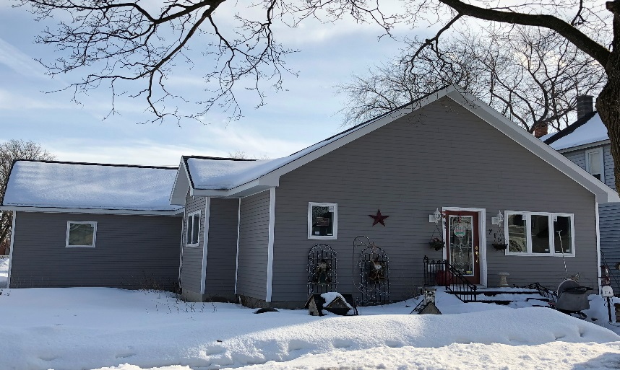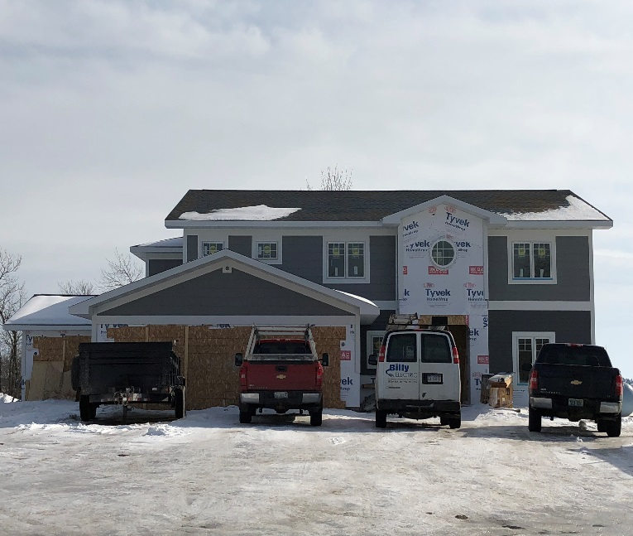Last year the city decided to go through the County to provide building inspections. 2017 was the first full year the county provided this service for us. We are still required to complete a zoning approval for each site to ensure the development meets zoning codes that are in place and the county ensures that all State building codes are met. Overall the transition went off without a hitch. Most contractors are used to working with the County Inspector and so the transition for them was relatively smooth. The county issued 25 building permits in 2017 on behalf of the City. Of these 25 permits, 20 of them were for residential activity. While largely the permits consisted of remodeling, additions and garages three residential homes were built. Because most of the development was in residential, the estimated value of construction is down considerably from last year but the amount of residential activity is still quite impressive. In comparison, the City of Escanaba added 2 new homes in 2017.

715 Minnesota Avenue

6 Sunrise Lane

## BUILDING PERMITS ISSUED-2017

|  |
| --- |
| Type of Building Permit (20 Total) Value of Construction  * Remodel/Addition 5 $2,783,445.00 * Garage 8 * Decks/Porch 3 * Demolition 1 * New Commercial 5   + 2 Storage Units (Lincoln Fair Storage)   + Storage Building (City)   + Office (Naser Oil)   + Bank (Upper Peninsula State Bank      * New Homes 3   + 713 Minnesota   + 6 Sunrise Lane   + 33 Royal Oak Drive |

**CODE ENFORCEMENT**

Del Johnson, our Property Maintenance Official works closely with Public Safety and various departments to handle property maintenance issues. He handled 350 property maintenance complaints in 2017. Many of the complaints involve properties that are neglected or owners that need to be reminded to be good neighbors. Del’s position averages 15 hours a week. Del travels south in the winter months so Kristin was trained to handle snow complaints while he is away. This has helped ensure that sidewalks remain open during the snowy season and provides for better consistency within our department.

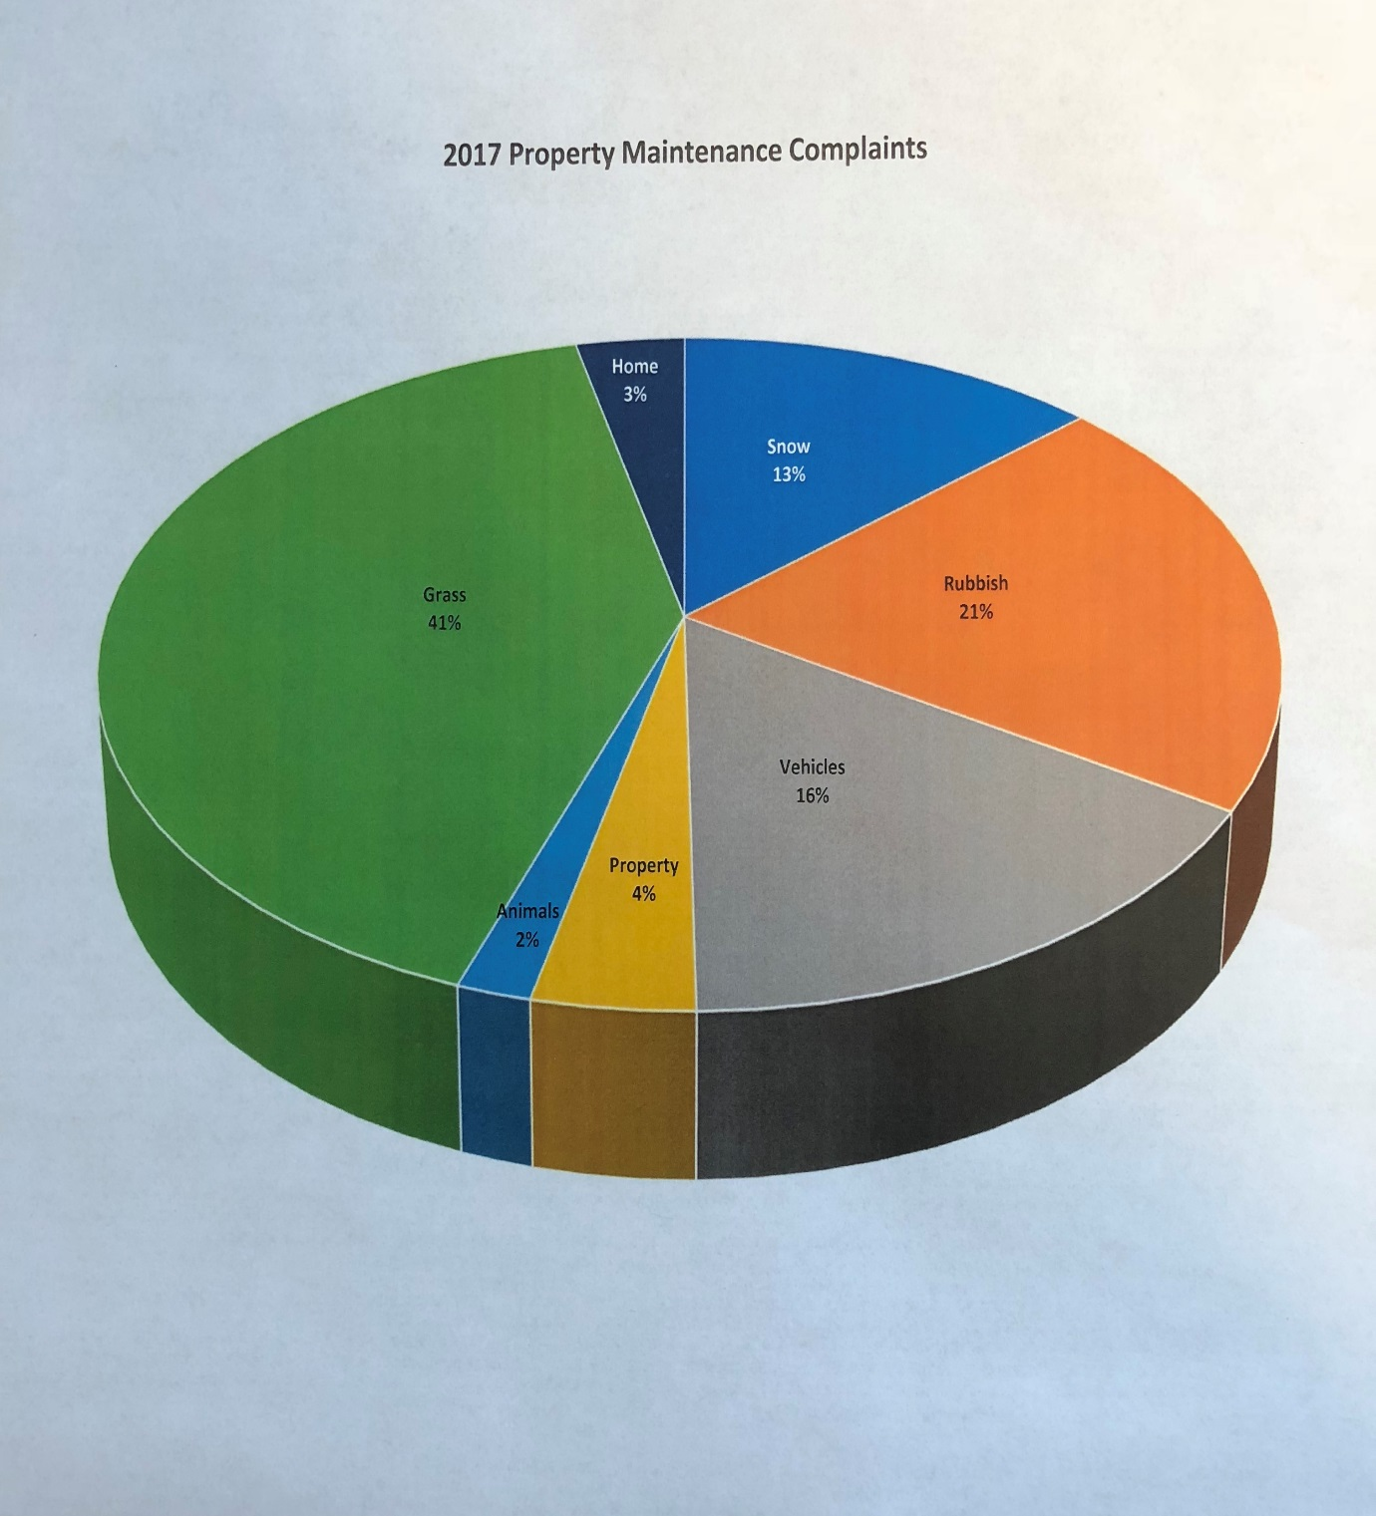

**350 Complaints Handled in 2017**

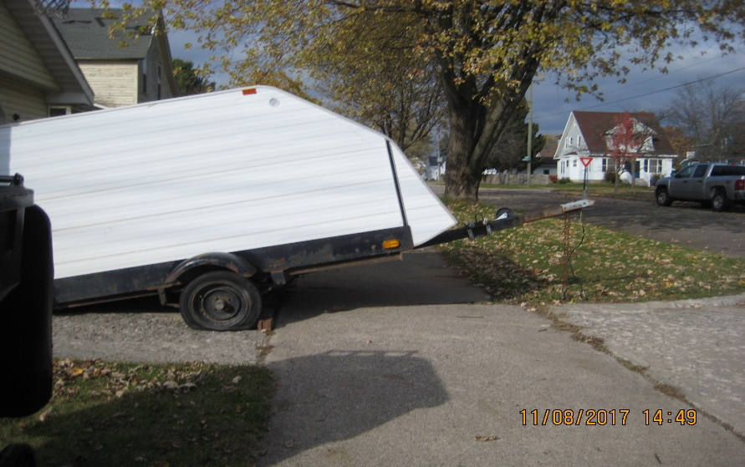

**Trailer Over Sidewalk**

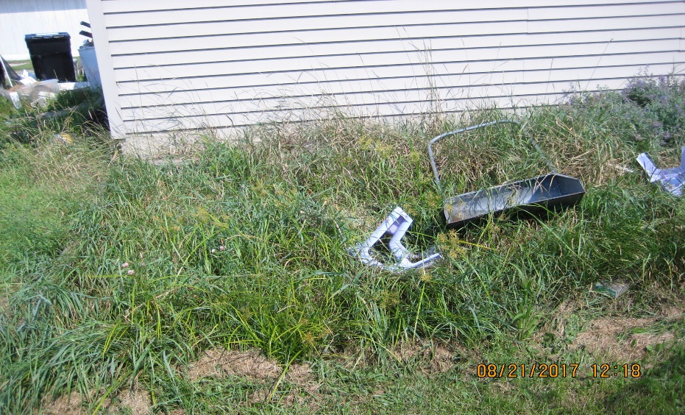

**Long Grass & Debris**

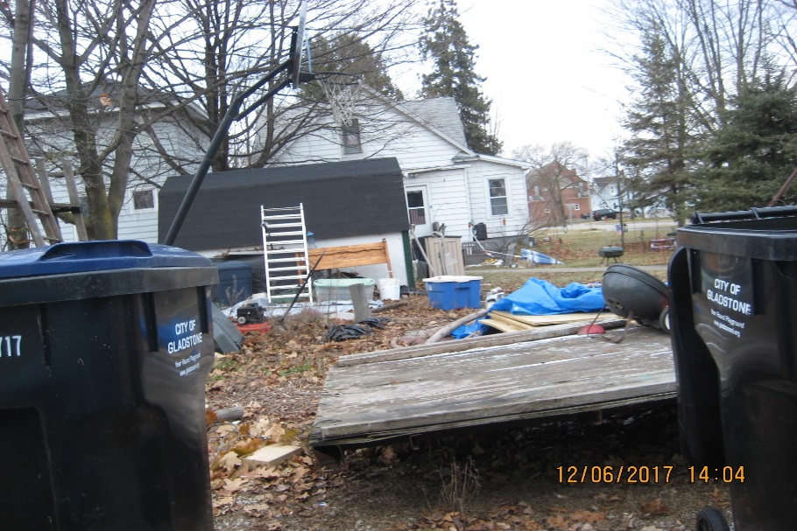

**Yard Debris**

# City of Gladstone Planning Commission

**Priorities & Budget Recommendations**

**2018-2019**

## PRIORITIES

The Planning Commission suggests the following areas receive priority for the upcoming fiscal year.

* Trainings
* Continued GIS Mapping
* Continued Codification
* Professional Planning to address Flex Zoning and other zoning deficiencies identified through the Master Plan

**Trainings** are a key component of a functioning Planning Commission. Commissioners and/or ZBA members will attend and seek training as needed. Two new commissioners are on board this year but they bring a wealth of talent and experience. Local trainings will be utilized whenever possible to minimize expenses.

**GIS Mapping** is critical to enabling the Zoning Administrator to carry out job functions. The City has made great strides in the development of its GIS capabilities. The Planning Commission continues to support further development of GIS to enable all departments and residents access to these services

**Codification/Professional Planning:** When new ordinances are adopted they need to get into the code (called codification). An accurate and up-to-date code is a key component to ensure the Planning Commission, the Zoning Administrator and others make accurate decisions regarding any zoning/planning issue. Each time an ordinance is created or updated the Municode system will track them and keep an up to date version available to the public and staff. Profession Planning is a valuable resource to the Planning Commission and assists us on occasion when expert planners are needed to help guide and direct activities.

The Planning Commission will need to address some areas within the zoning code to adopt the Flex Zoning district. We will work with planners and other experts to work through these requirements. Funding will be sought from outside resources to accommodate this process but some local funds will have to be expended.

## BUDGET RECOMMENDATIONS

Below are budget recommendations to support the activities and priorities of the Planning Commission for the upcoming 2017-2018 fiscal year. These budgetary items remain the same as the previous year.

Office Supplies (paper, envelopes, general office supplies) $ 500.00

Postage (Mailing to PC & Residents as needed) $ 400.00

Membership Dues (MAP) $ 60.00

Subscription fee (PCJ) $ 55.00

Telephone $ 600.00

Transportation & Lodging (Mileage & Hotels for trainings) $ 600.00

Education & Training $ 500.00

Printing & Publishing (Public Hearing Notices to Paper) $ 700.00

GIS Mapping $ 500.00

Codification $ 1000.00

Copier Rental (Rental Fee) $ 450.00

**Total Recommended Budget $5,365.000

These budget amounts are incorporated into the overall Community Development Budget and/or other City Budgets and if possible supplemented through grants and other funding sources.

\*\**This budget recommendation* ***does not*** *include staff time and/or staff expenses to support the Planning Commission or its priorities.*